Constructing Angles by Combining

Definition
# Source: AI Source: Provided by: [Data Path: Persons Table -> ID Column: 1, Name_En Column: Motasem Essam] -> From: [ChatGPT] on [7/25/2026]
Constructing angles by combining is a geometric construction method in which new angles are created by adding, subtracting, or repeatedly bisecting already constructed angles.
Instead of constructing every angle directly, existing constructible angles are used as building blocks to obtain additional angles.
For example:
$$\boxed{{90}^{∘}+{45}^{∘}={135}^{∘}} \\ \boxed{{90}^{∘}-{60}^{∘}={30}^{∘}} \\ \boxed{\frac{{90}^{∘}}{2}={45}^{∘}}$$

Fundamental Concept
# Source: AI Source: Provided by: [Data Path: Persons Table -> ID Column: 1, Name_En Column: Motasem Essam] -> From: [ChatGPT] on [7/25/2026]
Suppose two constructible angles are:
$$α$$
and
$$β$$
Then new angles can be constructed by:
Addition
$$\boxed{θ=α+β}$$
Subtraction
$$\boxed{θ=α-β}$$
Bisection
$$\boxed{θ=\frac{α}{2}}$$
Repeated Bisection
$$\boxed{θ=\frac{α}{2^{n}}}$$
where:
$$n=1,2,3,…$$
Thus, many angles can be generated from a small set of basic angles.

1. Angle Addition
# Source: AI Source: Provided by: [Data Path: Persons Table -> ID Column: 1, Name_En Column: Motasem Essam] -> From: [ChatGPT] on [7/25/2026]
Angle addition combines two angles to form a larger angle.
If:
$$α={60}^{∘}$$
and:
$$β={30}^{∘}$$
then:
$$\boxed{θ={60}^{∘}+{30}^{∘}={90}^{∘}}$$
Construction Idea
- Construct the first angle.
- Place the second angle adjacent to the first.
- The resulting angle is their sum.

2. Angle Subtraction
# Source: AI Source: Provided by: [Data Path: Persons Table -> ID Column: 1, Name_En Column: Motasem Essam] -> From: [ChatGPT] on [7/25/2026]
Angle subtraction removes one angle from another.
If:
$$α={90}^{∘}$$
and:
$$β={60}^{∘}$$
then:
$$\boxed{θ={90}^{∘}-{60}^{∘}={30}^{∘}}$$
Construction Idea
- Construct the larger angle.
- Construct the smaller angle inside it.
- The remaining region is the required angle.

3. Angle Bisection
# Source: AI Source: Provided by: [Data Path: Persons Table -> ID Column: 1, Name_En Column: Motasem Essam] -> From: [ChatGPT] on [7/25/2026]
Bisection divides an angle into two equal parts.
If:
$$θ={60}^{∘}$$
then:
$$\boxed{\frac{{60}^{∘}}{2}={30}^{∘}}$$
If:
$$θ={90}^{∘}$$
then:
$$\boxed{\frac{{90}^{∘}}{2}={45}^{∘}}$$
An angle bisector is used for this construction.

4. Repeated Bisection
# Source: AI Source: Provided by: [Data Path: Persons Table -> ID Column: 1, Name_En Column: Motasem Essam] -> From: [ChatGPT] on [7/25/2026]
Repeated bisection produces smaller constructible angles.
For example:
$${90}^{∘} \\ {45}^{∘}=\frac{{90}^{∘}}{2} \\ {22.5}^{∘}=\frac{{45}^{∘}}{2} \\ {11.25}^{∘}=\frac{{22.5}^{∘}}{2} \\ {5.625}^{∘}=\frac{{11.25}^{∘}}{2}$$
Thus:
$$\boxed{θ_{n}=\frac{θ_{0}}{2^{n}}}$$
Repeated bisection is an important method for constructing many angles.

Common Angle Combinations
# Source: AI Source: Provided by: [Data Path: Persons Table -> ID Column: 1, Name_En Column: Motasem Essam] -> From: [ChatGPT] on [7/25/2026]
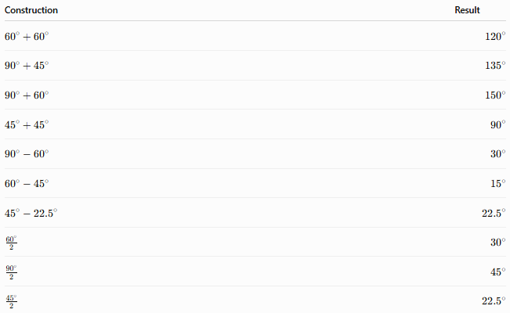
Construction | Result
$${60}^{∘}+{60}^{∘}$$ | $${120}^{∘}$$
$${90}^{∘}+{45}^{∘}$$ | $${135}^{∘}$$
$${90}^{∘}+{60}^{∘}$$ | $${150}^{∘}$$
$${45}^{∘}+{45}^{∘}$$ | $${90}^{∘}$$
$${90}^{∘}-{60}^{∘}$$ | $${30}^{∘}$$
$${60}^{∘}-{45}^{∘}$$ | $${15}^{∘}$$
$${45}^{∘}-{22.5}^{∘}$$ | $${22.5}^{∘}$$
$$\frac{{60}^{∘}}{2}$$ | $${30}^{∘}$$
$$\frac{{90}^{∘}}{2}$$ | $${45}^{∘}$$
$$\frac{{45}^{∘}}{2}$$ | $${22.5}^{∘}$$

Examples

Example 1: Constructing ${135}^{∘}$
# Source: AI Source: Provided by: [Data Path: Persons Table -> ID Column: 1, Name_En Column: Motasem Essam] -> From: [ChatGPT] on [7/25/2026]
Construct:
$${90}^{∘}$$
Construct:
$${45}^{∘}$$
Combine them:
$$\boxed{{135}^{∘}={90}^{∘}+{45}^{∘}}$$

Example 2: Constructing ${15}^{∘}$
# Source: AI Source: Provided by: [Data Path: Persons Table -> ID Column: 1, Name_En Column: Motasem Essam] -> From: [ChatGPT] on [7/25/2026]
Construct:
$${45}^{∘}$$
Construct:
$${30}^{∘}$$
Subtract:
$$\boxed{{15}^{∘}={45}^{∘}-{30}^{∘}}$$

Example 3: Constructing ${75}^{∘}$
# Source: AI Source: Provided by: [Data Path: Persons Table -> ID Column: 1, Name_En Column: Motasem Essam] -> From: [ChatGPT] on [7/25/2026]
Construct:
$${45}^{∘}$$
Construct:
$${30}^{∘}$$
Add:
$$\boxed{{75}^{∘}={45}^{∘}+{30}^{∘}}$$

Example 4: Constructing ${150}^{∘}$
# Source: AI Source: Provided by: [Data Path: Persons Table -> ID Column: 1, Name_En Column: Motasem Essam] -> From: [ChatGPT] on [7/25/2026]
Construct:
$${90}^{∘}$$
Construct:
$${60}^{∘}$$
Add:
$$\boxed{{150}^{∘}={90}^{∘}+{60}^{∘}}$$

Relationship to Other Constructions
# Source: AI Source: Provided by: [Data Path: Persons Table -> ID Column: 1, Name_En Column: Motasem Essam] -> From: [ChatGPT] on [7/25/2026]
Constructing angles by combining depends on other geometric constructions:
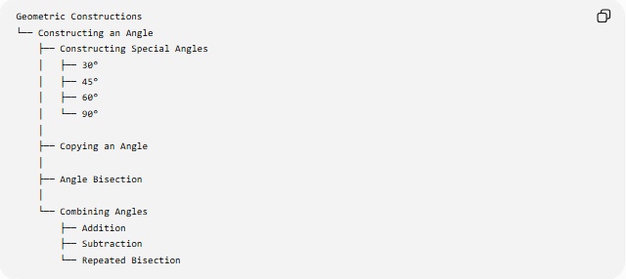
Geometric Constructions
└── Constructing an Angle
├── Constructing Special Angles
│ ├── 30°
│ ├── 45°
│ ├── 60°
│ └── 90°
│
├── Copying an Angle
│
├── Angle Bisection
│
└── Combining Angles
├── Addition
├── Subtraction
└── Repeated Bisection
This classification follows the earlier structure for angle construction.

Main Characteristics
# Source: AI Source: Provided by: [Data Path: Persons Table -> ID Column: 1, Name_En Column: Motasem Essam] -> From: [ChatGPT] on [7/25/2026]
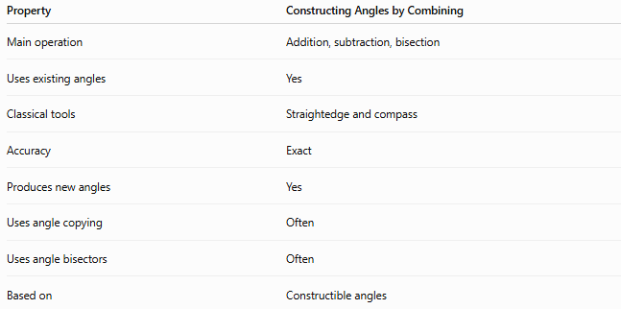
Property | Constructing Angles by Combining
Main operation | Addition, subtraction, bisection
Uses existing angles | Yes
Classical tools | Straightedge and compass
Accuracy | Exact
Produces new angles | Yes
Uses angle copying | Often
Uses angle bisectors | Often
Based on | Constructible angles

Important Idea
# Source: AI Source: Provided by: [Data Path: Persons Table -> ID Column: 1, Name_En Column: Motasem Essam] -> From: [ChatGPT] on [7/25/2026]
Not every angle is directly constructed from scratch.
Many angles are obtained from:
$${30}^{∘}, {45}^{∘}, {60}^{∘}, {90}^{∘}$$
using:
$$+, -, ÷2$$
For example:
$${75}^{∘}={45}^{∘}+{30}^{∘} \\ {15}^{∘}={45}^{∘}-{30}^{∘} \\ {22.5}^{∘}=\frac{{45}^{∘}}{2}$$
Thus:
$$\boxed{\text{Complex Angles}=\text{Special Angles + Geometric Operations}}$$

Classification
# Source: AI Source: Provided by: [Data Path: Persons Table -> ID Column: 1, Name_En Column: Motasem Essam] -> From: [ChatGPT] on [7/25/2026]
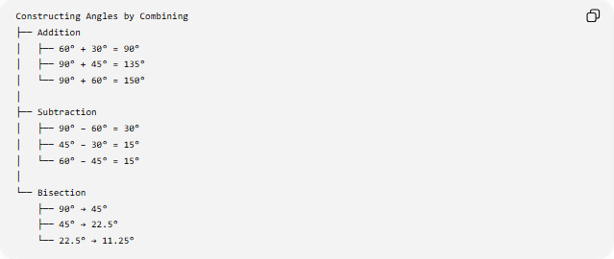
Constructing Angles by Combining
├── Addition
│ ├── 60° + 30° = 90°
│ ├── 90° + 45° = 135°
│ └── 90° + 60° = 150°
│
├── Subtraction
│ ├── 90° − 60° = 30°
│ ├── 45° − 30° = 15°
│ └── 60° − 45° = 15°
│
└── Bisection
├── 90° → 45°
├── 45° → 22.5°
└── 22.5° → 11.25°

Key Formulas
# Source: AI Source: Provided by: [Data Path: Persons Table -> ID Column: 1, Name_En Column: Motasem Essam] -> From: [ChatGPT] on [7/25/2026]
Angle Addition
$$\boxed{θ=α+β}$$
Angle Subtraction
$$\boxed{θ=α-β}$$
Angle Bisection
$$\boxed{θ=\frac{α}{2}}$$
Repeated Bisection
$$\boxed{θ=\frac{α}{2^{n}}}$$

Key Points
# Source: AI Source: Provided by: [Data Path: Persons Table -> ID Column: 1, Name_En Column: Motasem Essam] -> From: [ChatGPT] on [7/25/2026]
- Constructing angles by combining uses previously constructed angles.
- The main operations are:
  - addition,
  - subtraction,
  - bisection.
- Many angles are obtained from ${30}^{∘}$, ${45}^{∘}$, ${60}^{∘}$, and ${90}^{∘}$.
- Repeated bisection produces increasingly smaller constructible angles.
- Angle combination is an exact geometric construction method.
- It relies on copying angles and angle bisectors.
- This method greatly expands the set of constructible angles.

Conclusion
# Source: AI Source: Provided by: [Data Path: Persons Table -> ID Column: 1, Name_En Column: Motasem Essam] -> From: [ChatGPT] on [7/25/2026]
Constructing Angles by Combining is a geometric construction method in which new angles are produced through addition, subtraction, and repeated bisection of already constructed angles.
$$\boxed{\text{New Angle}=\text{Existing Angles + Geometric Operations}}$$
This method allows many exact angles to be constructed using only a straightedge, compass, and previously constructed angles.

